Small Schemes - BUSINESS CASE
for
South East - Local Sustainable Transport Programme
(SE LSTP)

Please note that this proforma is designed to collect key information about the project. The scheme promoters are encouraged to attach any additional supporting information to this business case proforma.

Project type (rail, road, LSTP, integrated package, maintenance etc.): SEP LSTP Scheme
Size of Project: Small (total project cost is below £8m)
Project Location: South Essex
Project start date: April 2015
Project complete date: March 2017
Project development stage: Design

Promoting authority name: Essex County Council
Project Manager’s name and position: Anthony Buston
Project Manager’s contact phone number: 03330 136698
Project Manager’s email address: anthony.buston@essex.gov.uk

Specify the web link where this business case will be published:

Version Control
Document ID | SE LSTP Business Case 250215
Version | 01
Author | Dave Joy
Document Status | Draft
Authorised by | Alastair Southgate
Date Authorised | February 25, 2015
Signature

The Strategic Case
- Project Description
  - Purpose
The purpose of this project is to improve and integrate existing passenger transport networks, supporting infrastructure and systems to create opportunities for seamless sustainable travel across South Essex, including the unitary areas of Southend and Thurrock. Also, this will unlock additional transport capacity, which would otherwise prevent economic growth and development. This will be an initiative based on the Government’s ‘Door to Door’ strategy and supplemented / enhanced by a South Essex (SE) wide Local Sustainable Transport Fund approach.

This proposal is a major catalyst to deliver sustainable growth in the regeneration area of South Essex. It draws together all of the necessary components of an integrated door to door public transport network - information, interchange and improved services. The SE area comprises growth locations that strongly relate to each other economically. There are clear existing commuting patterns between them, mainly by car, and this is likely to be accentuated by the forecast levels of economic growth across the area. This is likely to result in increased car use, congestion on key inter-urban routes and increased carbon dioxide emissions. This pattern is coupled with leisure trips across the area, generated by sub-regional attractions, such as the Lakeside Shopping Centre, the retail park in Thurrock and the seafront in Southend-on-Sea.

The South Essex Transport & Land Use Model (SETLUM) predicts increasing traffic congestion and longer journey times:
- 20-25% slower traffic speeds on major roads by 2016
- 0-15% slower traffic speeds on local roads by 2016

However, there is an extensive and varied public transport network in the SE area, comprising of 27 rail stations, two train franchises and a number of longer distance inter-urban bus services. Despite this, and although London-bound trains in the morning peak and trains out of London in the evening peak are very well utilised, evidence shows that non-London related peak services and most off-peak services have considerable spare capacity. Furthermore, a number of highway pinch-points cause delays to buses and hinder the ability to ensure good punctuality. There is a clear opportunity to promote better connectivity across the area, through improved utilisation of public transport infrastructure and services, enabling people to gain access to employment, education and leisure opportunities using public transport. As a consequence, this scheme will improve connections with rail, in order to make the public transport network more efficient.

Benefits to the network have already been witnessed previously in both Southend and Thurrock through previous investments in the network. In the Southend case, investment obtained through the Better Bus Area Fund has demonstrated the improvements of journey time savings through targeted bus punctuality measures. This has included specific improvements at key locations such as the installation of real time information and a taxi rank at the Southend Hospital, to provide options for the travelling public. Leigh Rail Station forecourt has been changed to increase safety, giving easier access with enhanced facilities, including an expanded taxi rank, disabled drop off, new bus shelters with lighting and information signs, and it also includes a public information kiosk which gives direct real time information about rail services. These measures, accompanied by other congestion management schemes in the area, have resulted in an average 14% improvement since congestion measures have been introduced. Similar work has been successful in Thurrock.

This proposal seeks to improve the strategic public transport network dramatically across the SE area by fully integrating it and providing an efficient and recognised network. This will act as a vital catalyst to help achieve sustainable regeneration and growth, focusing on the provision of a comprehensive, accessible, connected and efficient public transport network. The project looks to focus on utilising the existing train network and the existing best performing, frequent express bus services that combine to make a complete public transport network, which, through enhanced connections with rail, will connect the sub-region, especially the growth areas of Basildon, Southend and Thurrock. It will build on the several million pounds already invested by the local transport authorities on the Automatic Vehicle Location (AVL) system - a technological platform that will enable real time information, bus priority and the resultant benefits that they bring. Some measures have already been implemented, including on-street information displays and i-kiosks, however, there is some way to go to make the network more comprehensive. Modal shift is a significant over-arching objective of the scheme, by having a comprehensive transport network that enables trip-chaining, especially around key transport corridors and interchanges, which is defined further in the Policy Context chapter.

  - Brief description
The scheme will specifically include a focus on improvements to the existing passenger transport network by providing the latest AVL / RTPI information facilities; by improving bus stop hardware at key locations along major routes within the SE area, and by introducing improvements on key routes which cross boundaries, in and out, of SE. It will also provide improved and new cycle links to facilitate a more continuous public transport chain by removing gaps in the cycling network. Additionally, there is a specific focus on passenger infrastructure improvements at two major rail stations – Rayleigh and Rochford.

These improvements will be concentrated along key corridors of strategic movement, such as access to Basildon Hospital, towards London Southend Airport (LSA), the expanding business parks around LSA, Lakeside and Grays. The figure below shows what the scheme could look like, which will be refined as the scheme progresses.

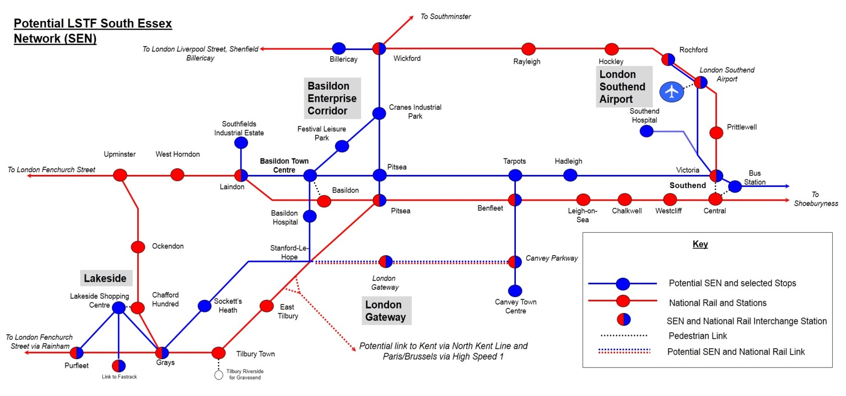
  - Strategic context
The package of schemes acts as a vital catalyst to help achieve regeneration and growth, focusing on the provision of an accessible, connected and efficient transport network.

The schemes are required to overcome the constraints of an existing transport network which is exceeded in capacity terms. It will provide the opportunity to introduce a range of measures which will unlock additional capacity by removing a volume of traffic from the network. As these routes in the network are the main access corridors to business within the SE area, the improvements generated will enable reliable, predictable and safe journeys along the strategic road network that are essential to support growth and regeneration in South Essex. Specifically, they will provide opportunities for new businesses in growing sectors and additional employment opportunities.

The SE area is part of the major employment hub of the region, which includes both the A127 and A13 strategic corridors that connect London and the M25 to Basildon and Southend (including London Southend Airport). The package of schemes supports the regeneration of Basildon town centre and improves connections to Basildon Enterprise Corridor (the largest employment area in Essex with in excess of 30,000 jobs). It will be an enabler to release further land for business development, by providing improved access to employment and supporting development in and around Southend Airport. It will help ensure that South Essex is an attractive location to invest, and for companies to grow, with easy access to potential employees, markets and suppliers, including those based in London. This is complimented by the London Southend Airport Access (Joint Area Action Plan) which will provide over 7,000 jobs in the area. The JAAP was supported at the 2014 Evidence in Public by the Inspector, and is now formally adopted as planning policy.

From London through Thurrock to Basildon and Canvey Island, the A13 corridor is the largest single growth opportunity in the SE LEP area. With DP World’s £1.5bn investment in London Gateway - the UK’s 21st century container sea port, along with Europe’s largest logistics park - the A13 is an essential link in the nation’s trunk road network. A new business park at Canvey Island is also planned, as well as significant regeneration of Canvey Town Centre, along with a number of key facilities for education and jobs across the South Essex area. All of these projects will require enabling investment in transport infrastructure.

The A127 links London with Basildon, Rochford and Southend. In Basildon, this corridor is home to one of the largest single concentrations of advanced manufacturing companies in the South of England. It makes substantial contributions to the prosperity of the SE LEP area and offers considerable growth prospects.

London Southend Airport, with scheduled air services to Europe and hub airports for onward global travel, and its neighbouring business park, is proving attractive to a wide range of global companies and offers capacity for at least 4,200 additional jobs up to 2021, and a further 3,180 post 2021. Comprehensive redevelopment plans for Basildon Town Centre are well advanced, including the relocation of South Essex College’s Basildon Campus to the Town Centre.

Realising much of this growth depends upon addressing the significant capacity issues along the A127. At peak periods, the A127 carries traffic volumes which exceed those on many urban motorways elsewhere in the UK. Along the A127 corridor, there is potential to directly enable the creation of 8,775 jobs and 1,450 new homes by 2021, and a further 48,927 jobs and 32,655 homes through proposed transport schemes.

Investment in this corridor is wholly compliant with the aspirations of the Economic Plan for Essex (EPfE) that updates and incorporates the Greater Essex Integrated County Strategy (ICS) and the ECC Economic Growth Strategy. The package of improvements proposed supports the delivery of the Essex Local Transport Plan, and has the support of the partner authorities.

Essex County Council has the stated ambition to make Essex the location of choice for business and to be a county where innovation brings prosperity:
- To grow, the Essex economy depends on the efficient movement of people, goods and information, via effective and reliable transport and communications networks providing access to markets and suppliers. It is therefore essential that the infrastructure that enables Essex residents to travel, and their businesses to grow, is developed and maintained;
- Essex’s support for employment and entrepreneurship across the local economy needs to be focused on ensuring a ready supply of development land, new housing, and the coordinated provision of appropriate infrastructure.

Thurrock Council’s Vision states “Thurrock; A place of opportunity, enterprise and excellence where individuals, communities and businesses flourish”. Thurrock Council sets five Strategic Priorities designed to achieve its Vision:
- Create a great place for learning and opportunity
- Encourage and promote job creation and economic prosperity
- Build pride, responsibility and respect
- Improve health and wellbeing
- Protect and promote our clean and green environment

This project for investment in sustainable infrastructure is essential to aid in the delivery of these ambitions.

Key Policy Links:

Strategic Economic Plan
Southend-on-Sea Borough Council, Essex County Council and Thurrock Council plan to work with the South
East Local Enterprise Partnership (SE LEP) in the planning and delivery of the proposed package of measures. The SE LEP has considered the proposal contained within this bid and has prioritised it against other bids in the SE LEP area. The SE LEP Strategic Economic Plan includes details of its ongoing support for this Local Sustainable Transport Fund proposal in Section 4.83 of the Strategic Economic Plan. Further details of LSTP schemes can be found in Appendix B of the Strategic Economic Plan.

The South East Local Enterprise Partnership is fully supportive of the need to make better public transport connections across TGSE. This is reflected in a letter of support from SELEP for the scheme in 2014 (found in Appendix E alongside other letters of support). Investment in better public transport connections across the south of Essex improves connectivity along and between two key corridors that form the focus of investment in the A13 London-Thurrock-Canvey Island corridor and the A127 London-Basildon-Southend corridor.

The SEP states that the A13 corridor through Thurrock to Basildon and Canvey Island is the largest single
growth opportunity in the SE LEP area, with DP World's £1.5bn investment in London Gateway container port and logistics park and Lakeside, already Europe’s largest retail complex. The A127 corridor links London with Basildon and Southend. In Basildon, the A127 corridor is home to one of the largest single concentrations of advanced manufacturing companies in the South of England. It makes substantial contributions to the prosperity of the SE LEP area and offers considerable growth prospects. London Southend Airport, now with scheduled air services to Europe and hub airports for onward global travel, and its neighbouring business park, is proving attractive to a wide range of global companies. Southend Central (including Victoria Avenue) is a major new town centre quarter for new offices, including the City Deal secured Growth Hub, and housing. Comprehensive redevelopment plans for Basildon Town Centre are well advanced, including the relocation of South Essex College's Basildon Campus to the Town Centre. Currently, development is constrained by the limited capacity of the road network that will, in part, be addressed by this bid.

As a result, the LSTP proposals will address the following SEP priorities:
• Promoting innovation and smart specialisation: Improved public transport links across the sub-region, which is home to several major existing, new and proposed transport and logistics operations, should help to reduce congestion and free up road network capacity to support growth within the transport and logistics industry. It will also help to ensure that excellent sustainable access is available so that growth industries will have access to a wider pool of staff and skills across the sub-region.
• Accelerating business starts and growth: Encouraging a modal shift to public transport should help to reduce congestion across the sub-region, thus freeing up road network capacity in order to facilitate growth, particularly in areas where transport has historically been seen as a constraint to employment growth and development.
• Increasing trade and attracting investment: Improved public transport links and reduced congestion across the sub-region should help to increase trade with and attract investment from our international partners.

Department for Transport’s Door to Door strategy
The LSTP proposals will also contribute towards the Government’s Door to Door Strategy. In particular, the
real time passenger information will improve the availability and dissemination of sustainable travel information through current technologies to help residents better plan sustainable door to door journeys (Door to Door Priority 1), coupled with the emphasis of improving links to transport interchanges through cycling, enabling more effective trip-chaining. Making fuller use of the capabilities of the AVL system will enable real time passenger information and bus priority to improve connectivity and efficiency, in general, improving connections between walking, cycling and public transport to increase choice (Door to Door Priority 3). Improved information, bus priority and real time passenger information will improve transport interchanges between sustainable modes, particularly to bus and rail, to make it easier to change modes during a journey (Door to Door Priority 4).

The Essex Transport Strategy (LTP3)
The 2015/16 joint LSTP proposals will help to meet following The Essex Transport Strategy aims to:
- Provide connectivity for Essex communities and international gateways to support sustainable economic growth and regeneration
- Reduce carbon dioxide emissions and improve air quality through lifestyle changes, innovation and technology
- Provide sustainable access and travel choice for Essex residents to help create sustainable communities.

In particular, the proposal will assist in meeting the Essex Transport Strategy Thames Gateway priorities for:
- Providing for and promoting access by sustainable modes of travel to new development areas;
- Improving public transport links within and between the Thames Gateway towns
- Improving the availability of sustainable travel choices and raising public awareness of these through travel planning;
- Improving the attractiveness and ease of use of public spaces to support regeneration;
- Improving journey time reliability on strategic inter-urban routes including the A127, A129, A130 and the A13;
- Improving access to London Gateway port and Southend Airport.

Essex County Council’s approach to improving the attractiveness of local bus services includes:
- Ensuring that accurate, consistent and up-to-date information is available on local services through a range of media (including Real Time Passenger Information) and in a manner in which it can be clearly understood by all.

Essex County Council Corporate Outcomes Framework 2014-2018
This sets out the seven high level outcomes that ECC want to achieve to ensure prosperity and wellbeing for Essex residents. Securing these outcomes will make Essex a more prosperous county; one where people can flourish, live well and achieve their ambitions.

The seven outcomes are listed below:
• Children in Essex get the best start in life
• People in Essex enjoy good health and wellbeing
• People have aspirations and achieve their ambitions through education, training and lifelong- learning
• People in Essex live in safe communities and are protected from harm
• Sustainable economic growth for Essex communities and businesses
• People in Essex experience a high quality and sustainable environment
• People in Essex can live independently and exercise control over their lives.

Southend Local Transport Plan 3 (See also Appendix D)
The Southend Local Transport Plan 3 (LTP3) aims to:
- Have a thriving and sustainable local economy
- Minimise environmental impact, promote sustainability for a greener Borough
- Create a safer Borough
- Reduce inequalities in health and wellbeing and for a more accessible Borough.

With a focus on bus use, the Southend LTP3 looks to work with bus operators to:
- Encourage behavioural change through a wide programme of bus priority measures across the Borough, particularly to encourage non-car trips to the town centre.
- Make full use of technology to facilitate the shift to sustainable modes, such as ITS, VMS, and Real Time Passenger Information (RTPI).

In addition, Southend-on-Sea Borough Council will continue to work with bus and train operators to ensure regeneration is supported by an adequate provision of public transport. In the case of buses, a programme of
bus priority measures, and, in the case of railway stations, the development of facilities to promote all sustainable modes carefully integrated with bus services and facilities.

Thurrock Transport Strategy: 2012 – 2026 (See also Appendix D)
The LSTP proposal will also help to meet several of Thurrock Council’s LTP objectives, including:
- ACC1: To improve accessibility to services, especially education, employment and hospitals
- CON1: To encourage a modal shift away from the private car to walking, cycling and public transport, especially to work and school
- CON2: To encourage a modal shift for freight from Heavy Goods Vehicles onto rail and water
- CON3: To improve bus satisfaction
- CON4: To minimise traffic growth
- CON5: To increase public transport patronage
- AQ&CC4: To reduce carbon dioxide emissions from transport
- REG1: To promote economic regeneration by reducing congestion
- REG2: To promote social regeneration by delivering accessibility

The Thurrock Transport Strategy also looks to target initiatives which increase awareness of public transport
use and opportunities by:
- Providing improved public transport timetables at boarding points;
- Working in partnership with others, especially public transport operators;
- Taking advantage of new technologies, building on real time passenger information already installed
- and focusing further enhancements at key interchanges and on interurban public transport routes;
- Improving public transport interchanges;
- Delivering public transport priority measures where possible and where necessary;
- Better and more bus shelters, with real time passenger information; and
- Improved public transport ticketing arrangements.

LSTP Fund Objectives
The LSTP proposal will meet the LSTP fund objectives by supporting the local economy and facilitating economic development by further reducing congestion through modal shift to public transport in the TGSE area. The reliability and predictability of journey times on strategic routes will be improved by facilitating a modal shift away from car use to public transport. Journey times and reliability will also be improved for public transport users, particularly through the application of real time passenger information and bus priority.

Finally, the LSTP proposals will work to reduce carbon dioxide emission from road transport by increasing the volume and proportions of journeys made by public transport through intensive marketing and promotion of, and improvements to, public transport journeys.

Case for Change
- Business needs / Reasons
      - Outline the rationale for making the investment with reference to the problems with the status quo.
The South Essex transport network is a vitally important lifeline for the movement of goods and people. It is essential to ensure the area connects more efficiently with the M25, in particular, the importance of Thurrock’s immediate proximity to junction 30/31, and connections with Basildon and Southend (including London Southend Airport). If improvements to this corridor are not provided, then the area will not see the appropriate levels of investment and growth which will be to the detriment of existing road users and residents. There will be a missed opportunity to make changes to the road network which will act as the catalyst to support economic growth and development at strategic level.
Key outcomes will include the following:
- Support the growth of housing and employment through making better use of the existing transport network
- Improved perception of journey reliability and punctuality of strategic bus services
- Develop a comprehensive intermodal strategic public transport network
- Improve satisfaction with strategic public transport services and information
- Deliver a modal shift from car use to public transport use for inter-urban journeys, especially to help facilitate the sustainable travel to and from new employment sites
- Improve integration between sustainable modes of transport, especially between bus, rail and cycling
- Make better use of the under-utilised off peak bus services
- Reduce traffic congestion and improve network efficiency for public transport operators
      - What evidence is there of need for the project?
Transport network improvements with, and to, key strategic employment locations within the key Essex locations of Basildon, Castle Point and Rochford, Southend and Thurrock are necessary to support significant economic growth and development in the area.
Castle Point, for example, with its emerging industrial areas such as the Charfleets Industrial Estate and Manor Road Trading Estate has been identified for strong levels of growth.
It is clear that, if these areas are to grow, incremental housing will be needed to support the increase in jobs and then additional pressure will be placed on the road network. Because of significant levels of car dependency, without a credible alternative, in terms of public transport, as well as improvements in journey times and road capacity, this growth will be stifled. This package of multi-modal schemes would therefore provide the impetus and ability for businesses and housing to expand across the region, enabling a much improved flow of goods and business through an efficient and accessible transport network, whilst, at the same time, facilitating a more strategically managed road network.
The South Essex population of approximately 345,000 is projected to increase by over 30,000 within the next seven years. South Essex plans for significant regeneration and growth with an additional 19,300 homes and 16,000 jobs, all proposed by 2021. These figures are a further indication of the underlying need to improve the areas around the employment hubs and airport to aid the growth in the most efficient way possible. This will provide improved access to employment, ensuring that South Essex is an attractive location to invest and for companies to grow, by providing easy access to potential employees, markets and suppliers, including London and Europe.

Uncertainty, such as when the next bus will arrive, can be a significant barrier preventing people from using public transport. Users of public transport increasingly expect real time information to both plan their journeys and reduce uncertainty. Meeting passenger expectations is a key priority of both the bus operators and the three transport authorities within SE, and the provision of more accurate real-time information about bus journeys increases the attractiveness and functionality of the public transport system. Electronic displays at bus stops are to be provided at strategic locations, with priority given to key routes, to inform waiting passengers. The signs are based alongside bus stops, providing details of the route, destination and accurate departure times.

The provision of sustainable and accessible transport is a key element of meeting Thurrock Council’s planned growth of 23,250 homes (17,330 net still to build) and 26,000 jobs to 2026. Reductions in traffic flows and congestion will allow for increased capacity and journey reliability to facilitate this level of growth and regeneration. The LDF aims to reduce traffic growth through a 10% reduction in car traffic from 2026 forecast levels in order to ensure housing and employment growth come forward. The Council’s approach for achieving this reduction is through public transport, walking and cycling improvements. The continuation of elements of the Local Sustainable Transport Fund (LSTF) programme will be integral to locking in modal shift benefits achieved from the programme to date and ensuring that traffic growth is minimised. The Council, through its LSTF programme, already actively engages with the local community and business sectors. Prominent local businesses are represented on the LSTF Project Board.

At Southend and Rochford, the new Saxon Business Park will host one of Med Tech campuses, adjacent to London Southend Airport. London Southend Airport has undergone a transformational regeneration programme and is now an award-winning international gateway. The £130m development of the airport has been privately funded by the Stobart Group with support from Southend, Rochford and Essex Councils and local businesses. The land, on which the airport and the surrounding commercial estates are located, spans the political boundary between Southend and Rochford. Accordingly, the authorities have jointly commissioned a Joint Area Action Plan (JAAP) which contains detailed proposals for the development of London Southend Airport and surrounding area to deliver more than 7,380 new jobs within 99,000sqm of commercial floorspace together with a high end business park. The transport package supporting the JAAP area includes site access, junction improvements and a range of sustainable transport measures.

This LSTP scheme is essential in providing the sustainable transport framework required to enable growth and development and to reduce the demands placed on an already saturated road network. Currently, development is constrained by the limited capacity of the strategic road network, particularly J30/31 of the M25 and the dual carriageway stretch of the A13, although work on improvements to J30/31 has just started. The A127 also carries a volume of traffic comparable to a motorway in other parts of the country and has significant capacity issues which need to be addressed, particularly around Basildon, London Southend Airport and the Southend Central Area. Southend Borough Council and Essex County Council have developed a joint “A127 Corridor for Growth” economic plan to identify, plan and coordinate investment decisions and manage the asset. Furthermore, the potential impact of the additional Thames River crossing would be significant on transport routes in this corridor, with one of the two short-listed options being to connect the M2 in Kent with the A13 and the M25 between junctions 29 and 30.

This is backed up by the recent National Highways & Transportation Survey 2014 which illustrates the levels of dissatisfaction with the public transport network. In the case of Essex, 34% of respondents were satisfied with the quality of electronic display information (Southend 42%), 55% were satisfied with the local bus service overall (68% Southend). Only 40% of respondents were satisfied with information availability (48% for Southend). This feedback assists in providing the evidence for the substantial need to improve the quality of information and passenger experience at bus stops. This project is a key catalyst in resolving these negative issues as a major step in increasing the number of public transport users through a better quality network.
      - What impact does the scheme have on releasing the growth or overcoming barriers to growth?
The current issues experienced within the strategic road network which constrain economic growth and development within the SE area include:
- Major congestion around the employment hubs in Basildon, Castle Point and Rochford, Southend and Thurrock especially during peak periods, which prevents the efficient movement of goods and people
- Significant constraints on general traffic and public transport services experienced through a number of pinch points on the strategic road network, which have exceeded levels of capacity and cause congestion on the road network
- An absence of alternatives to the private car, through an ineffective public transport network, has resulted in a car dependent culture. This package of schemes will enable the steps necessary to provide a joined-up sustainable transport network, which will respond to the latent demand for public transport, as well as providing a realistic alternative to the private car, and increasing the uptake in the use of public transport
- Current poor provision of public transport information and lack of a comprehensive network approach would benefit from real time information signs, Smart Ticketing and branding of an efficient public transport network
- Currently, little inter-modal opportunity or trip-chaining opportunities. Improvements will be achieved through this suite of measures which will adopt an integrated travel approach by bridging the gap between bus, rail and cycling so that there is an easy transition between these modes.

A significant shift to public transport is required to accommodate the regeneration travel needs from the new homes and jobs to be provided in the area, as well as an increased uptake of other sustainable methods such as cycling and walking. Although some capacity improvements to rail services are planned through other channels, these are unlikely to do more than relieve some of the existing congestion problems on the network, and would not provide for the increased demand that would occur due to demographic changes and developments already underway. The rail improvements would principally improve longer distance travel east-west through SE, and would not significantly benefit those travelling between towns within the area, or seeking to travel north-south. Improvements to existing bus services could provide more capacity, but are unlikely to provide the high level quality of service and reliability necessary to encourage a shift from car to public transport without significant improvements to passenger information techniques.

      - What will happen if the proposed project is not funded from LGF?
To deliver the necessary improvements in public transport, we need to increase both the capacity and quality of service which requires a significant shift to public transport. Unless this is provided, the existing road and public transport networks will become even more congested and overcrowded than at present, and accessibility within SE will continue to decline.
Additionally, it is clear that the remaining regeneration and growth schemes are interdependent on delivering South East LSTP improvements, as they will provide improved access to employment, ensuring that South Essex and Thurrock are attractive locations to invest and for companies to grow.

      - Is there a potential to reduce costs and still achieve the desired outcomes?
This is a scalable package of measures and reduction in scheme funding will have a proportionate effect on delivery and, consequently, the benefits outcome.

- Benefits
    - Estimate jobs and homes (direct, indirect, safeguarding, construction etc)

The SE Essex LSTP bid will directly support 21,192 new jobs and 11,868 new homes and will also support 7,380 jobs and 3,731 new homes identified with the Southend Airport JAAP, which is subject to a separate business case.

 | 2015/16 | 2016/17 | 2017/18 | 2018/19 | 2019/2020 | 2020/2021 | Post 2021 | Total
Jobs | 3,532 | 3,532 | 3,532 | 3,532 | 3,532 | 3,532 | 0 | 21,192
Homes | 1,978 | 1,978 | 1,978 | 1,978 | 1,978 | 1,978 | 0 | 11,868
      - Describe the methodology of how the number of jobs and homes is estimated

The forecast increase in jobs and homes has been well established through various studies and it has been assumed that the delivery of new jobs and homes is flat-rated over the period, as per above.
      - List all main direct and indirect; quantitative and qualitative; cash releasing and non cash releasing benefits associated with the investment
- Risks
  - Provide a summary of key risks to the delivery of the scheme (including financial, commercial, economic and management).

  - Risk Assessment
Risk description | Likelihood | Impact | Likelihood x Impact | Mitigation | Owner
Stakeholder / Partnership opposition or management issues, public and / or organisational issues (please see table 1 below) | 2 | 3 | 6 | Conduct stakeholder analysis by drawing up a power- influence matrix and develop robust plans for stakeholder management and communications including providing public information when necessary. Establish joint governance arrangements and early partnership work. | ECC / SBC / TDC
Statutory Processes: Planning, PI, Orders, CPO | 1 | 5 | 5 | There are unlikely to be any barriers of this nature affecting these proposals, however some traffic orders may be required | ECC / SBC / TDC
Finance: escalation of project costs | 3 | 3 | 9 | Project costs will be carefully monitored as projects progress. However, the entire package is scalable, if required | ECC / SBC / TDC
Programme overrun; delivery issues | 2 | 3 | 6 | All potential impacts will be reviewed regularly, but no significant issues are likely. Extensive use of existing delivery capabilities through term contracts etc. | ECC / SBC / TDC / Ringway Jacobs
Technical project risks | 3 | 3 | 9 | Impact of utilities on delivery – regular early discussions proposed | ECC / SBC / TDC / Ringway Jacobs
Tender prices at variance with estimates leading to re-design or scheme cancellation | 4 | 4 | 16 | Obtain other recent tender information for use in price base comparison | ECC / SBC / TDC / Ringway Jacobs
Weather hinders or delays the works | 2 | 2 | 4 | Introduce programme float to cover potential slippage | Ringway Jacobs
C3 prices at variance with estimates leading to re-design or scheme cancellation | 4 | 4 | 16 | Ensure C3 and C4 requests are issued with sufficient time to allow for modifications | ECC / SBC / TDC / Ringway Jacobs
Discovery of undeclared utilities during construction | 4 | 4 | 16 | Undertake GPR surveys and timely trial holes | Ringway Jacobs
Discovery of contaminated ground or material on site | 3 | 3 | 9 | Undertake timely site investigation | Ringway Jacobs
Unforeseen ground conditions - re-design required | 3 | 3 | 9 | Undertake timely site investigation | Ringway Jacobs
Claims from nearby residents on noise and vibration | 3 | 3 | 9 | Undertake pre-construction monitoring. Ensure contractor is aware of NVH responsibilities | Ringway Jacobs
Invasive species found on-site, additional cost for site clearance | 1 | 1 | 1 | Unlikely, but undertake site survey | Ringway Jacobs
Construction cost escalation | 4 | 4 | 16 | Undertake pre-construction monitoring | Ringway Jacobs
Unforeseen discovery of protected species. | 1 | 1 | 1 | Undertake surveys for protected species, early site clearance | Ringway Jacobs
Contractor fails on delivery timing resulting in programme overrun | 3 | 4 | 12 | Tender scheme using appropriate quality questions to identify potential issues | ECC / SBC / TDC / Ringway Jacobs
Cost and time overrun associated with mitigating Tree Preservation Orders | 2 | 2 | 4 | Survey trees and develop mitigation early | ECC / SBC / TDC / Ringway Jacobs
Table 1 – Stakeholder Engagement and Communication Plan
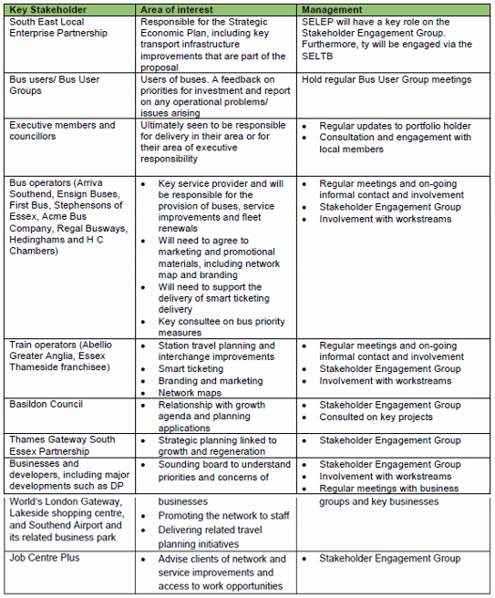

The Economic Case
- Options
  - Please provide a description of the main options for investment, together with their relative advantages and disadvantages (a SWOT analysis)

Strengths:  - Recognised growth area of national significance – South Essex is a national priority for investment  - Well-established partnership working with a track record of delivery by both public and private sectors  - Strong and unique connectivity to London and South East markets, to Europe and other international markets via excellent ports and airports  - Committed major private sector investments – London Southend Airport, London Gateway, Lakeside expansion, Tilbury expansion etc.  - High employment rate, especially in a number of important sectors such as advanced manufacturing and engineering, transport & logistics, and retail  - High business birth rates  - Significant environmental and historical assets  - Cultural, leisure and tourism assets  - Served by two major commuter railway lines with good connectivity to London | Weaknesses:  - Major road congestion at peak times on principal roads, junctions and in town centres  - 50% of short trips by car  - East west access to M25 reliant on two strategic routes - A127 and A13  - Productivity below the national average  - Low business survival rates  - Pockets of deprivation / disconnected communities  - Poor quality industrial estates and premises  - Lack of land available for development in some areas  - Disconnected public transport links  - Poor public transport information provision  - Poor or non-existent bus stop hardware  - Lack of connected cycleways  - External image / pre-conceived perceptions  - Lack of secure cycle storage at key railway stations
Opportunities:  - Fully utilise the sub-region’s exceptional land, labour and capital assets to achieve its economic and growth potential  - Potential for “smart growth” – growth delivered through higher productivity and by bringing more of the resident population into economic activity  - Potential to build business resilience and growth through SME diversification / internalisation in strong core sectors  - Potential to increase employment in knowledge-intensive sectors  - Important location for housing development  - Potential to capitalise upon economic and infrastructure assets of national and international importance  - Making east – west transport links more resilient to incidents and congestion  - Fully realise the potential of economic links with London, including capacity to accommodate growth to the East of London  - Scope for further improvements in the highway and rail network, as demonstrated by previous schemes, delivering major benefits | Threats:  - Global challenge - increasing the region’s competitiveness in the face of intensifying international competition  - Vulnerability from high dependence on a relatively small number of major Foreign Direct Investment (FDI) companies  - Significant change at the next General Election (2015) may bring changes in policies and investor confidence  - Potential decline of London as a world financial services centre  - Prevailing economic conditions may discourage private sector investment, including bringing forward key development sites  - Continuing / increasing threat to town centre viability  - Failure to build an environment (skills, infrastructure, housing) that attracts high value-adding, innovative businesses  - Continued growth of low value employment stunting economic growth and increasing the level of under-employment  - Public concern that growth will lead to increased congestion as a result of failure to invest in adequate infrastructure improvement

The SE LSTP bid will serve the key urban centres of Basildon, Castle Point, Rochford, Southend and Thurrock districts, providing the population with the necessary infrastructure to enable economic growth, regeneration and development. It should be noted that the programme of schemes is scalable in terms of implementation and funding. The impacts are defined in terms of outcomes below:
- Do Nothing
The South Essex transport network is a vitally important lifeline for the movement of goods and people, which due to its geographical position, needs to be upgraded to ensure the area connects more efficiently with the M25, Basildon and Southend (including London Southend Airport). If improvements to this corridor are not provided, as outlined in the package of measures above, then the area will not see investment and growth to the detriment of existing road users and residents. There will be a missed opportunity to make changes to the road network which would act as the catalyst to support economic growth and development at a strategic level.
- Do Minimum

Any ‘Do Minimum’ alternative would reduce the range of options within the package of schemes and will proportionately deliver less benefit.
- Do Something (best and final option; least net present cost option; highest risk adjusted NPV option; etc)

The focus will be centred on the urban areas of Basildon, Castle Point, Rochford, Southend and Thurrock linked with the roll-out of the AVL system, cycle link and station improvements to create a more comprehensive public transport network, including the following:

- Opportunities to relieve congested traffic routes by providing a sustainable alternative and linking with transport interchanges
- Enhancements to existing public transport corridors
- Significant improvements in passenger information and bus stop hardware leading to greater passenger confidence in the utilisation of public transport.

The intent would be to provide an efficient transport network linking between the following key SE locations:

- Basildon Bus Station
- Basildon Railway Station
- Basildon Town Centre
- Benfleet Station
- Billericay Railway Station
- Billericay Town Centre
- Canvey Island
- Charfleets Business Park, Canvey
- Lake Meadows Business Park, Billericay
- Lakeside Retail Park
- Lakeside Shopping Centre
- Leigh-on-Sea
- London Southend Airport
- London Southend Airport Business Parks – Aviation Way and Purdeys Way
- Rayleigh Railway Station
- Rochford Railway Station
- Shoeburyness
- Southend Town Centre
- Thurrock Business Parks / Industrial Area
- Wickford Railway Station
- Lakeside
- Grays Town Centre
- Stanford le Hope / London Gateway

  - Recommended Option: What is the preferred option – and why?
The preferred option is ‘Do Something’. This will ensure improvements are made to the key parts of the network that will improve journey time reliability and improve efficiency of the transport network to facilitate the growth of employment and housing.

5.4 Transport scheme assessment approach

5.4.1 Provide a brief description of a (spreadsheet-based) modelling and appraisal methodology as well as detail of data source used

Spreadsheet analysis has been conducted, particularly in relation to bus usage. See Appendix B and note on Economic Assessment.

5.4.2 List all assumptions made for transport modelling and appraisal – See Appendix B

5.4.3 Provide key positive and negative impacts of the schemes in the table below as described in the Appraisal Summary Table and Social Distribution Impact analysis, where it is appropriate, supported by evidence.

Category of impacts | Quantified/Qualitative impact | Large Beneficial to Large Adverse
Economy | Business users and providers  Reliability  Regeneration  Wider Impacts | Moderate Beneficial  Large Beneficial  Moderate Beneficial  Moderate Beneficial
Environment | Noise  Air Quality  Greenhouse gas  Landscape  Townscape  Heritage  Biodiversity  Water Environment | Slight Beneficial  Slight Beneficial  Slight Beneficial  Slight Adverse  Slight Adverse  Neutral  Neutral  Neutral
Social | Commuting & Other users  Accidents  Physical Activity  Journey Quality  Reliability Option and non-use values  Security  Access to Services  Affordability  Severance | Large Beneficial  Slight Beneficial  Large Beneficial  Large Beneficial  Slight Beneficial  Moderate Beneficial  Moderate Beneficial  Neutral  Neutral
Public Accounts | Cost to broad transport budget Indirect tax | Slight Beneficial

The scheme promoters are NOT required to use Tuba type appraisal analysis. If any scheme promoter is interested in estimating value for money then a spreadsheet based analysis should be undertaken.

Value for Money Statement
 | Present Values in 2010 prices and values
PVB | £ 21,857,017
PVC | £ 6,982,916
NPV = PVB - PVC | £ 14,874,101
Initial BCR = PVB / PVC | 3.13
Adjusted BCR | See Appendix
Qualitative Assessment | See Appendix
Key Risks, Sensitivities | See Appendix
VfM Category | High

Commercial Case
- Procurement Route
Briefly describe the procurement strategy. Set out the timescale involved in the procurement process to show that delivery can proceed quickly.

Procurement Strategy

The eastern Highways Alliance and SMARTe and the Highways Agency Framework have all been used extensively in prior major projects eg A176 Nether Mayne, A127 Cuckoo Corner, A127 Tesco Roundabout and Basildon Enterprise Corridor Road Improvements.

Construction will be delivered through the Essex Highways Service Direct Delivery Framework using supply chain partners.

The benefits of procuring the scheme through this route are:-

• Early involvement with the contractor
• Use of Supply Chain partners who are familiar with the delivery of smaller complex projects under tight deadlines.
• Flexibility and opportunity to accelerate the delivery of smaller elements through the ‘Walk, Talk and Build’ process, thus increasing confidence in project delivery timeframe.
• The utilisation of the Framework is endorsed by the ECC procurement team.
Risk Allocation
ECC, SBC and TDC will bear their respective risks for the project.
Maintenance
Work will be carried out on the existing highway network. All highway improvement works will be inspected annually and maintained by the relevant Highways Authority.

Financial Case
- Total cost of the project
List here the elements of gross costs, excluding optimisation bias.
Please provide the date the prices for the cost estimate is based on (e.g. Q1 2014)

 | * Cost Estimate status (E; F; D; T) | 2015/16  £000 | 2016/17  £000 | 2017/18  £000 | 2018/19  £000 | 2019/20  £000 | 2020/21  £000
Procurement Cost | D | 764.7
Feasibility Cost | D }
Detail Design Cost | D } | 882.7
Management Cost | D | 411.8
Construction Cost | D | 1973.6
Contingency | D | 170.0
QRA |  | 840.5
Stats |  | 346.9
VAT (if appropriate)
Sub-total Non-Works | D
Sub-total Works | D
TOTAL COST |  | 5390.3
*E = Broad estimate, D = Detailed estimate, T = Tender price, F= Feasibility estimate
- Source of funding
Funding Source | 2015/16  £000 | 2016/17  £000 | 2017/18  £000 | 2018/19  £000 | 2019/20  £000 | 2020/21  £000
LGF | 5,000.0
Private Developers
Borrowing
Income
Other (insert as many rows as required)
Local Contribution Total  ECC / LHPs  Thurrock | 213.5  41.0
Other Funding  AGA | 135.8
TOTAL FUNDING | 5,390.3

Please note that the totals for funding should match with the total for project cost.

Type of Funding | Funding Source | Please identify how secure the funds are | When will the money be available
Public | LGF | Agreed | From April 2015
 | Borrowing
 | Income
 | Other (insert as many rows as required)
 | Local Contribution Total  ECC / LHPs  Thurrock | Committed  Committed | From April 2015
Private | Please list all developers
 | Private Developers Total
 | Other Funding  AGA | Agreed | From April 2015

  - Affordability gap
- Is there an affordability gap? No

Management Case - Delivery
- Delivery
  - Provide high level information about arrangements that will ensure delivery of this project
Project plan:-

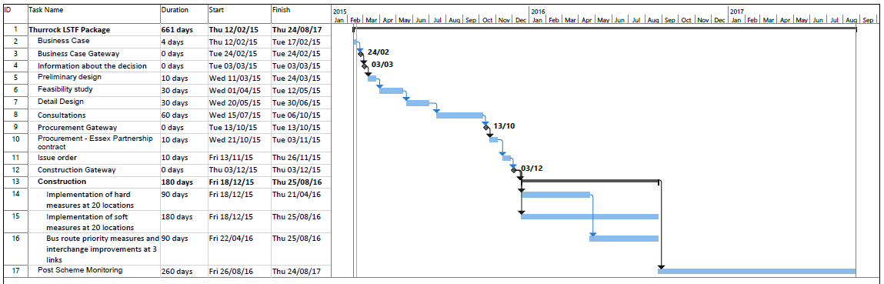

Project Management Arrangements and Governance

Background
This plan outlines the project structures and processes that will be used to govern activities.

Project Organisation
The organisation to deliver the scheme is indicated in Figure 1 below. The roles and responsibilities of the parties indicated in the figure are described in the following paragraphs. 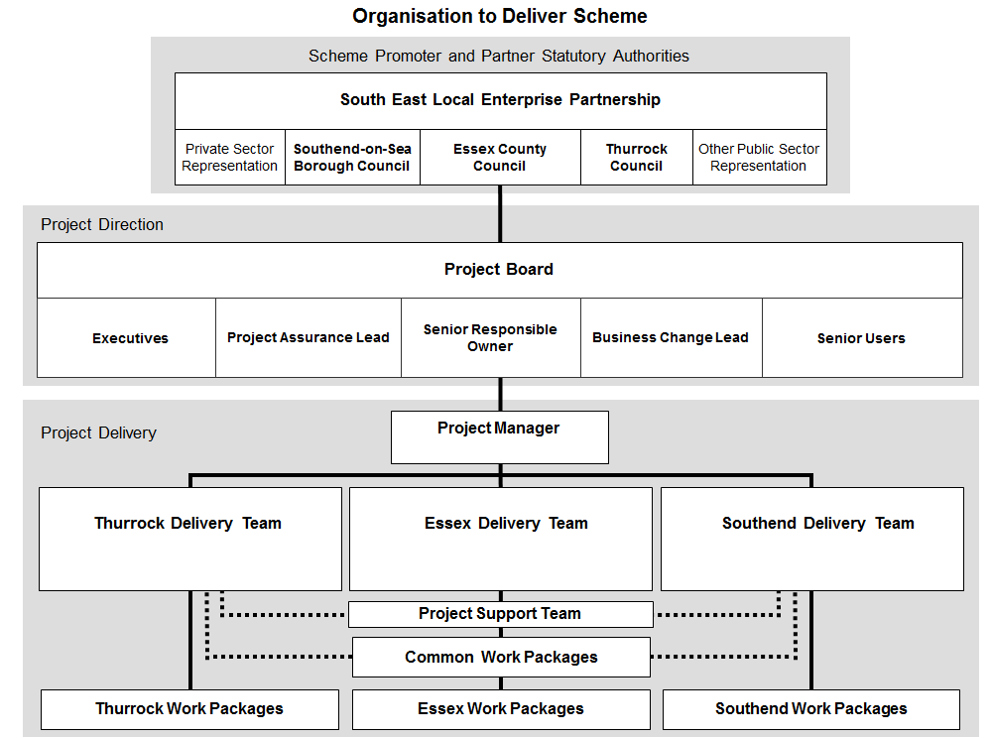
Figure 1: Arrangements for Scheme Delivery

Roles of Key Interested Parties:

South East Local Enterprise Partnership Board (SELEP) – brings together senior officers and transport portfolio holders of the three partner statutory authorities promoting the scheme – Essex County Council, Southend-on- Sea Borough Council and Thurrock Council. Essex County Council acts as the lead authority for the scheme and provides the project’s Senior Responsible Owner.

The arrangements between the statutory authorities promoting the scheme are in the process of being formalised through a joint working partnership agreement. This sets out the basis for governance of the project and for the financial contributions to be made by each party.

Project Board – is responsible for the direction and overall management of the scheme. The Project Board is chaired by the Senior Responsible Owner and made up of the Executive and Senior User for each of the partner statutory authorities, the Project Assurance Lead and the Business Change Lead. These roles are defined below. Project Board meetings are normally held every six weeks. The Project Manager reports regularly to the Project Board, keeping members informed of progress and highlighting any issues or concerns.

- The responsibilities of the Project Board include:
- Setting the strategic direction of the project, in the context of local policies and the work of the SELEP
- Defining the scope and setting the timescales for major project milestones
- Approving the appointment of the Project Manager
- Providing the Project Manager with the strategy and decisions required to enable the scheme to proceed to programme and resolve any challenges
- Securing necessary approvals through the partner statutory authorities
- Approving the project scope of work, programme and budgets, as well as any subsequent changes
- Signing off completion of each stage of the project and authorising the start of the next stage
- Monitoring project risks and taking any appropriate action to mitigate risks.

Delivery Teams – reporting to the Project Manager, the three Delivery Teams (one for each partner statutory authority) are responsible for organising and delivering work packages on the highways under the authority’s jurisdiction. The Essex Delivery Team has the additional responsibility for common work packages such as passenger information systems and service control technology.

Project Support – this team is responsible for project administration, including document control, project team communications, arranging meetings, updating plans, and chasing up the completion of actions.

Individual Roles:

Senior Responsible Owner (P Bird, ECC; A Lewis, SBC, A Osola, TDC) – has ultimate responsibility and delegated authority for ensuring effective delivery of the scheme on time and on budget.

Project Manager (B Gould, ECC, P Mathieson, SBC, D Freestone, TDC) – is the individual responsible for organising, controlling and delivering the scheme. The Project Manager leads and manages the project team, with the authority and responsibility to run the project on a day-today basis.

Executives – represent the group in each partner statutory authority with responsibility for obtaining funding for the scheme (C Stevenson, ECC) and securing resources to deliver it (D Stanesby, ECC). In Essex County Council this is the Transport Strategy and Engagement Group (B Gould, ECC), in Southend – P Mathieson and in Thurrock – D Freestone.

Senior Users (D Forkin, ECC) – represent the group in each partner statutory authority who will oversee the future day-to-day operation of the scheme.

Project Assurance Lead (E Deppe, Ringway Jacobs) – provides an independent view of how the scheme is progressing. Tasks include checking that the project remains viable in terms of costs and benefits (business assurance), the users' requirements are being met (user assurance), and that the project is delivering a suitable solution (technical assurance).

Business Change Lead – is responsible for facilitating internal and external transition required to support the successful establishment of the scheme.

Resources to support this project will be prioritized to ensure efficient delivery at the earliest opportunity.

Risk Management:
A proactive risk management procedure is in operation, including a quantified risk assessment approach, which ensures that risks are continuously identified, owners assigned and mitigation measures put in place. Regular reviews check the status of each risk and regulate their control and mitigation. Project procedures also require that should the likelihood or severity of risks be identified as increasing by this process, responsibility for its mitigation is escalated upwards through the project management chain to ensure that this is achieved.

All risks are currently owned by the partner authorities. As the project develops it is expected that some of these risks will be transferred to contractors constructing the infrastructure. In addition, Essex County Council uses a proprietary online Risk Register to assess levels of risk and to track the progress of the risk management strategy for the scheme. The §151 Officer also has access to this system. Risks are categorised into five main areas, i.e.:
- Project and programme risks related to delivery;
- Consultation and stakeholder acceptance;
- Reputational risks to the project partner authorities (and ultimately the contractors and service providers);
- Statutory Processes; and
- Financial and funding risks.

Stakeholder Management
A significant amount of consultation has already occurred regarding the scheme, which has received positive feedback from major employers and bus operators. A number of letters of support have been received for the scheme, which can be found in Appendix E. These key stakeholders will form part of the stakeholder engagement plan. In addition to this, the scheme is compliant with the recently published Essex Bus and Passenger Transport Strategy.

The objectives for the Stakeholder Engagement Plan include that it:
- Communicates and reinforces the branding of the network, once established;
- Improves awareness and understanding of the proposals;
- Allows the Project Board to obtain timely feedback on proposals;
- Helps gauge the level and nature of any opposition that may arise to the proposals and address these appropriately; and
- Enables the Project Team to explore the opportunities to establish a consensus, as the basis for successful implementation of the proposals.

Our overall aim is to involve key stakeholders as much as possible. We aim to actively involve key stakeholders in delivery and decision making through an effective stakeholder engagement process. This will include regular communications with bus operators, bus user groups, businesses and key employers such as DP World, Lakeside Regional Shopping Centre, and Southend Airport. Active engagement will also occur with train operators such as Abellio Greater Anglia, C2C and cycle groups such as Sustrans.
- Benefit realisation plan and monitoring

The level of technological specification involved within the delivery of the proposals and the monitoring programme for the 2015/16 LSTP will be accurate, thorough and robust. All three councils are keen to monitor and evaluate all elements of the LSTP, in order to gain a more in depth understanding of the outcomes of the investment made and to help determine and refine future delivery of similar projects. In summer 2016, we will aim to amalgamate all the information outlined below, in order to gauge the overall impact of the 2015/16 LSTP programme, by analysing the monitoring data from each element. General, high level indicators proposed for primary monitoring and evaluation will focus on four main elements:

- Public transport patronage and miles: Overall bus patronage along the affected route corridors will be analysed, with specific reference to any changes apparent immediately after the introduction of each individual element of the LSTP proposals. The number of users, following the introduction of the smartcard scheme for use on buses, will enable accurate monitoring regarding the number of passengers using the scheme, the distances they travel, the days the travel and where they ascend and alight.

- Bus punctuality: The bus priority system will automatically feed data back in terms of its use and application. In addition, we will continue to monitor bus punctuality along the route corridors covered by the 2015/16 LSTP proposals to determine the impact that the combination of measures has had on bus punctuality.

- Passenger transport user satisfaction: Upon completion of the 2015/16 programme, we propose to undertake an extensive public transport survey with TGN public transport users to determine whether satisfaction levels have increased. The smartphone app and website will be developed so as to be self-monitoring, by providing us with a continual data feed as to the number of users and visitor to the site.

4. Changes in area wide traffic mileage: At the highest levels, we will continue to monitor traffic levels across the Thames Gateway South Essex area, with a particular emphasis on pre- and post-implementation traffic monitoring along the inter-urban bus corridors, as well as the A13 and the A127.

- Contingency plans (if applicable)
- Independent Technical Evaluators’ sign off

SE LSTP

BENEFITS REALISATION PLAN SUMMARY

 | Benefits | Performance Indicator | Type* | When Delivered | Responsibility for Delivery | How Measured | Success Management
1. | Economy: Improve the economic efficiency and reliability of the local road network by reducing congestion on the main arterial roads. | LSTP | DFB | Completion of full scheme | ECC / Southend BC / Thurrock BC Project Managers | Measure pre-scheme peak period traffic flows, journey times baseline figures compared to post-opening.  After surveys within 3 months and then 1 year after scheme opening.  Surveys on existing & new network. | Based on PRINCE II Project Management principles. Project team will use established best practices for this type of scheme.
2. | Economy: Encourage more people to use sustainable travel with well-placed information boards, improved cycleway connections and improved railway station passenger infrastructure. | LSTP | DFB | Completion of full scheme | ECC / Southend BC / Thurrock BC Project Managers | Measure pre-scheme peak period traffic flows, journey times baseline figures compared to post-opening. | Based on PRINCE II Project Management principles. Project team will use established best practices for this type of scheme.
3. | Sustainability: Improve sustainability by providing improved AVL / RTPI information on major bus routes. | LSTP | DFB | Completion of full scheme | ECC / Southend BC / Thurrock BC Project Managers | Measure bus usage pre and post scheme. Conduct passenger surveys to measure levels of customer satisfaction. | Based on PRINCE II Project Management principles. Project team will use established best practices for this type of scheme.
4. | Sustainability: Improve sustainability by providing improved cycleway connections. | LSTP | DFB | Completion of full scheme | ECC / Southend BC / Thurrock BC Project Managers | Measure cycleway usage pre- and post- scheme. Conduct cycle surveys to measure levels of satisfaction. | Based on PRINCE II Project Management principles. Project team will use established best practices for this type of scheme.
5. | Sustainability: Improve sustainability by providing improved railway station passenger infrastructure. | LSTP | DFB | Completion of full scheme | ECC / Southend BC / Thurrock BC Project Managers | Measure railway passenger usage pre- and post- scheme. Conduct passenger surveys to measure levels of satisfaction. | Based on PRINCE II Project Management principles. Project team will use established best practices for this type of scheme.
6. | Economy: Provide improved and cost effective access to key locations. | LSTP | DFB | Completion of full scheme | ECC / Southend BC / Thurrock BC Project Managers | Measure car peak period traffic flows, journey times baseline figures compared to bus.  Surveys within 3 months and then 1 year after scheme opening. | Based on PRINCE II Project Management principles. Project team will use established best practices for this type of scheme.
7. | Accessibility: Facilitate access to stations and town centres. | LSTP | DFB | Completion of full scheme | ECC / Southend BC / Thurrock BC Project Managers | Conduct specific journey time surveys once scheme is complete. | Based on PRINCE II Project Management principles. Project team will use established best practices for this type of scheme.
8. | Integration: Integrate land-use, regeneration & transport policy by providing public transport infrastructure as part of the strategy for regeneration and growth. | LSTP | DNFB | During design and on completion of full scheme | ECC / Southend BC / Thurrock BC Project Managers | Undertake before and after infrastructure comparisons. | Liaise with other Councils throughout scheme design to ensure seamless scheme integration. Project teams will use established best practices for this type of scheme.
9. | Safety: Address congestion and capacity issues to the stations and town centres for residential, commuter and commercial traffic. | LSTP | DNFB | Completion of scheme | ECC / Southend BC / Thurrock BC Project Managers | Pre-scheme accident baseline figures compared to post opening.  After data collection within 1 year after scheme opening.  Figures from ECC accident data base supplied by Essex Police. | Based on PRINCE II Project Management principles. Project team will use established best practices for this type of scheme.
10. | Safety: Flows will be improved as traffic is taken out of the network. | LSTP | DNFB | Completion of scheme | ECC / Southend BC / Thurrock BC Project Managers | Pre-scheme accident baseline figures compared to post opening.  After data collection within 3 months and then 1 year after scheme opening.  Figures from ECC accident data base supplied by Essex Police. | Based on PRINCE II Project Management principles. Project team will use established best practices for this type of scheme.
11. | Environment: Ensure compliance with international, national, regional and local plans, policy and legislation. | ECC / Southend & Thurrock Locally Defined | IB | During design and on completion of full scheme | ECC / Southend BC / Thurrock BC Project Managers | All current and proposed legislation & policies will be adhered to.  Full consultation with all key local stakeholders during process. | Project team will use established best practices for this type of scheme.
12. | Environment: Minimise project programme slippages and delays through the early identification of environmental / topographical issues. | ECC / Southend & Thurrock Locally Defined | DFB | During design and on completion of full scheme | ECC / Southend BC / Thurrock BC Project Managers | Monitor progress regularly against programme until completion of scheme. | Undertake early Environmental and Topographical checks to avoid later issues. Project team will use established best practices for this type of scheme.

*Types: Direct Financial Benefit (DFB), Direct Non-financial Benefit (DNFB), Indirect Benefit (IB)

